TASK 1:
#include<iostream>
using namespace std;

int main()
{
int r,c;
bool check=true;
cout<<"Enter number of rows: ";
cin>>r;

cout<<"Enter number of columns: ";
cin>>c;

int **arr;
arr=new int*[r];

for(int i=0;i<r;i++)
{
arr[i]=new int[c];
}

for(int i=0;i<r;i++)
{
for(int j=0;j<c;j++)
{
cout<<"\nElement matrix ["<<i<<"]"<<"["<<j<<"]:";
cin>>arr[i][j];
}

cout<<"\n";
}
// cout<<"The entered elements are: ";
if(r!=c)
{
check=false;
}
else
{
for(int i=0;i<r;i++)
{
for(int j=0;j<c;j++)
{

if((i==j) && arr[i][j]!=1)
{
check=false;
break;
}
if((i!=j) && arr[i][j]!=0)
{
check=false;
break;
}
// cout<<"\nElement matrix ["<<i<<"]"<<"["<<j<<"]:"<<arr[i][j];

}
}
}

if(check)
{
cout<<"\nThis is an identity matrix!";
}
else
{
cout<<"\nThis is NOT an identity matrix!";
}

for(int k=0;k<r;k++)
{
delete[] arr[k];
}

delete arr;

arr=NULL;

return 0;

}
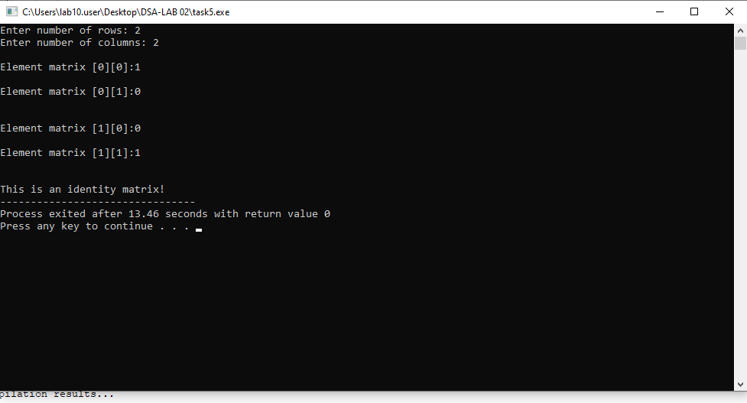

TASK 2:
#include<iostream>
using namespace std;

int main()
{
int n;
cout<<"Enter size of array: ";
cin>>n;

int *arr;
arr=new int[n];

for(int i=0;i<n;i++)
{
cout<<"\nElement "<<i+1<<": ";
cin>>arr[i];
}

int unique=0;

for(int i=0;i<n;i++)
{
bool dup=false;
for(int j=0;j<i;j++)
{
if(arr[i]==arr[j])
{
dup=true;
break;
}
}
if(!dup)
{
unique++;
}
}

int *newarr;
newarr=new int[unique];
int k=0;
for(int i=0;i<n;i++)
{
bool dup=false;
for(int j=0;j<i;j++)
{
if(arr[i]==arr[j])
{
dup=true;
break;
}
}
if(!dup)
{
newarr[k]=arr[i];
k++;
}
}
cout<<"\nUnique elements: \n";
for(int i=0;i<unique;i++)
{
cout<<newarr[i]<<endl;
}

delete[] arr;
delete[] newarr;

arr=NULL;
newarr=NULL;

return 0;
}
